**INTRODUCTION**

**OVERVIEW**

**This report discuss the result of the work done in ‘Alerting the Authorities about Intruder’ on Raspberry Pi. The project aims in creation of designing a camera module for solving the problem faced by soldiers at the border about intruder.**

**BACKGROUND AND MOTIVATION**

**Soldiers at the border face so many problems. However, the main problem are the security issues, which has been breached by infiltrators on the other side. Since soldiers cannot be posted at every location at the border, we are trying to provide a smart surveillance module that will work only when there is movement at border. It would be like hidden camera, which will not be seen by the infiltrator. It will only be known to the Authorities.**

**OBJECTIVE**

The final goal of the project is to provide information about the movement at the border at particular distance.

1. The camera module will activate only when there is movement at the border. If motion is detected, PIR Sensor is activated and camera is turned on. It will be active and monitor the environment for 2 minutes. If hostile activity is detected it will alert the authorities, capture the image, and store it on the cloud.
2. PIR Sensor will work only from certain distance.

**METHODOLOGY**

To implement the above goals, the following methodology needs to be followed:

1. Specifying the camera-working module.
2. Specifying the working of PIR Sensor.
3. Specifying the Raspberry Pi model
4. Specify the version of python.

**ANALYSIS**

**Based on the analysis and literature survey regarding the present difficulties faced by the military at the border about intruder, we decided to make this project as our IOT project to help the authorities to know about the activities that are happening at the border.**

**We made this possible by combining the camera and PIR Sensor at the border in which PIR Sensor will be activated after sensing any movement and it will make the camera active for visualizing and taking photos.**

**Secondly, we are also alerting the authorities by using buzzer that will activate along with the camera.**

**REQUIREMENT ANALYSIS**:

**SOFTWARE REQUIREMENTS**:

* **Raspbian OS**
* **Front end: PYTHON 3.7**
* **Dropbox**

**HARDWARE REQUIREMENTS:**

* **Raspberry Pi Model 3B**
* **Raspberry Pi Camera Module**
* **PIR Sensor**
* Buzzer
* **Jumper Wires**

**FUNCTIONAL REQUIREMENTS**:

1. **PIR Sensor detects if there is any movement in the environment.**
2. **Activates the camera module and start recording the surroundings.**
3. **Alert the authorities.**
4. **Stores the recorded visuals in Dropbox for future use.**
5. **Deactivates the camera after 2 minutes if no motion is detected.**

**NON-FUNCTIONAL REQUIREMENTS**:

1. **Availability**: It can be used by any government agencies where entry is restricted like Militarized zone, border etc.
2. **Maintainability**: Maintenance is very less as sensors are of high quality.
3. **Performance**: The data collected by the sensors are accurate as sensors sense precisely hence providing good performance to the user.
4. **Simplicity**: Since the device will be used by naïve personals who may be from a non-technical and technical background, the components have been made user friendly so that there will be lesser human interaction needed in order to work.

**TOOLS AND TECHNOLOGIES**:

**This product is built using Raspberry Pi 3 B, PIR Sensor, Dropbox and Python 3.7.**

The Raspberry Pi 3 B Model is the earliest of the third-Generation. It is powered by a 1.2 GHz BROADCOM BCM2837 processor with BCM43438 wireless LAN. It also has Bluetooth capabilities.

A passive infrared sensor (PIR sensor) is an electronic sensor that measures infrared (IR) light radiating from objects in its field of view. They are most often used in PIR based motion detectors.

The Raspberry Pi Camera Module v2 is a high quality 5 megapixel Sony IMX219 image sensor custom designed add-on board for Raspberry Pi. It has the capability to record videos and take pictures at a resolution of 5 megapixels.

Dropbox is a file hoisting service operated by the American company Dropbox Inc. that offers cloud storage. Dropbox helps us to store the captured images onto the cloud.

**DESIGN**

**CIRCUIT DIAGRAM**

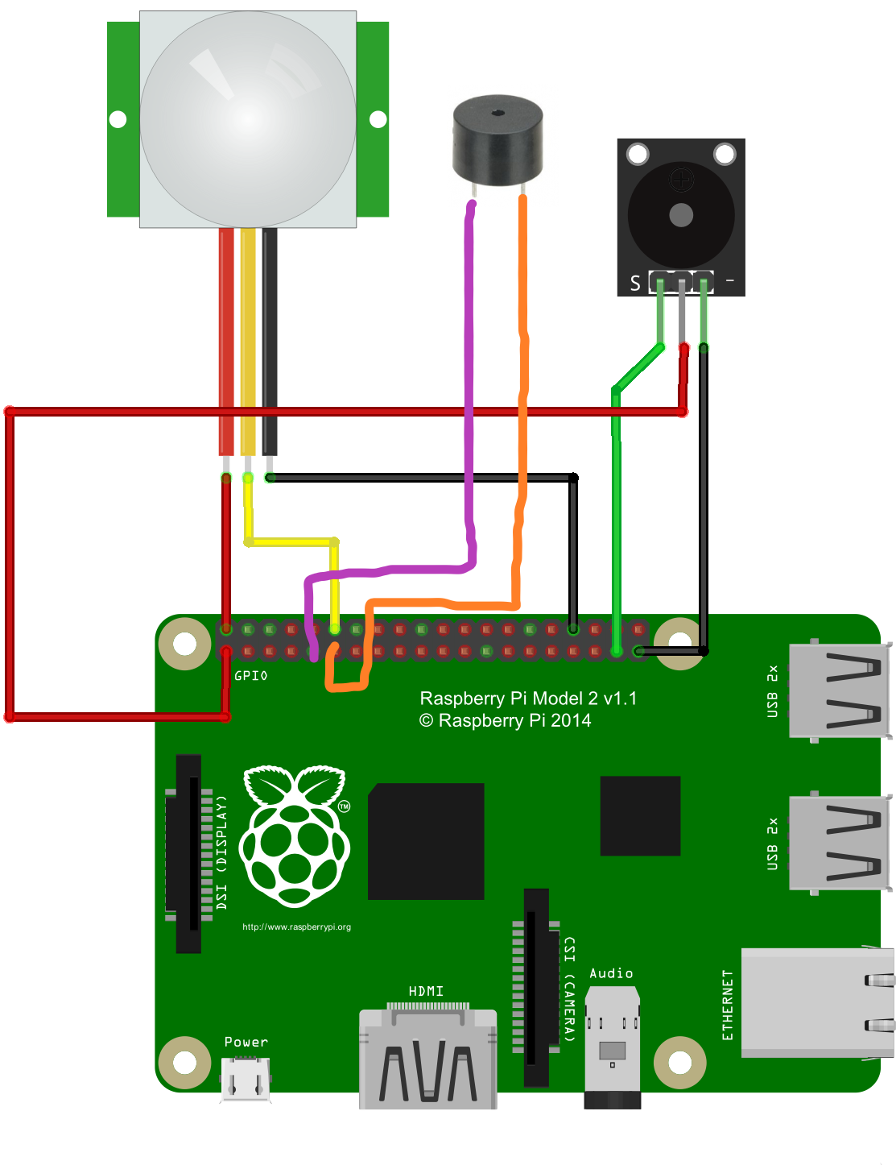

**BLOCK DIAGRAM**

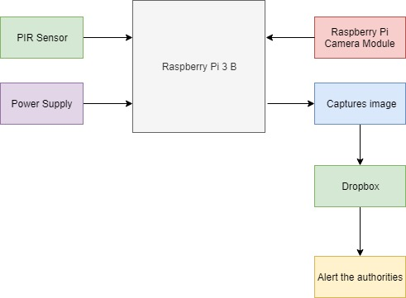

**FLOW DIAGRAM**

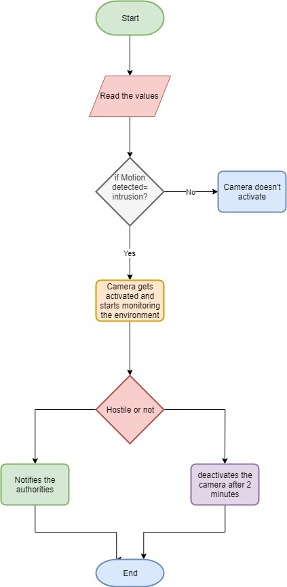

**SCREENSHOTS**

**CAMERA CAPTURING MOTION**



**IMAGE STORED ONTO THE CLOUD**

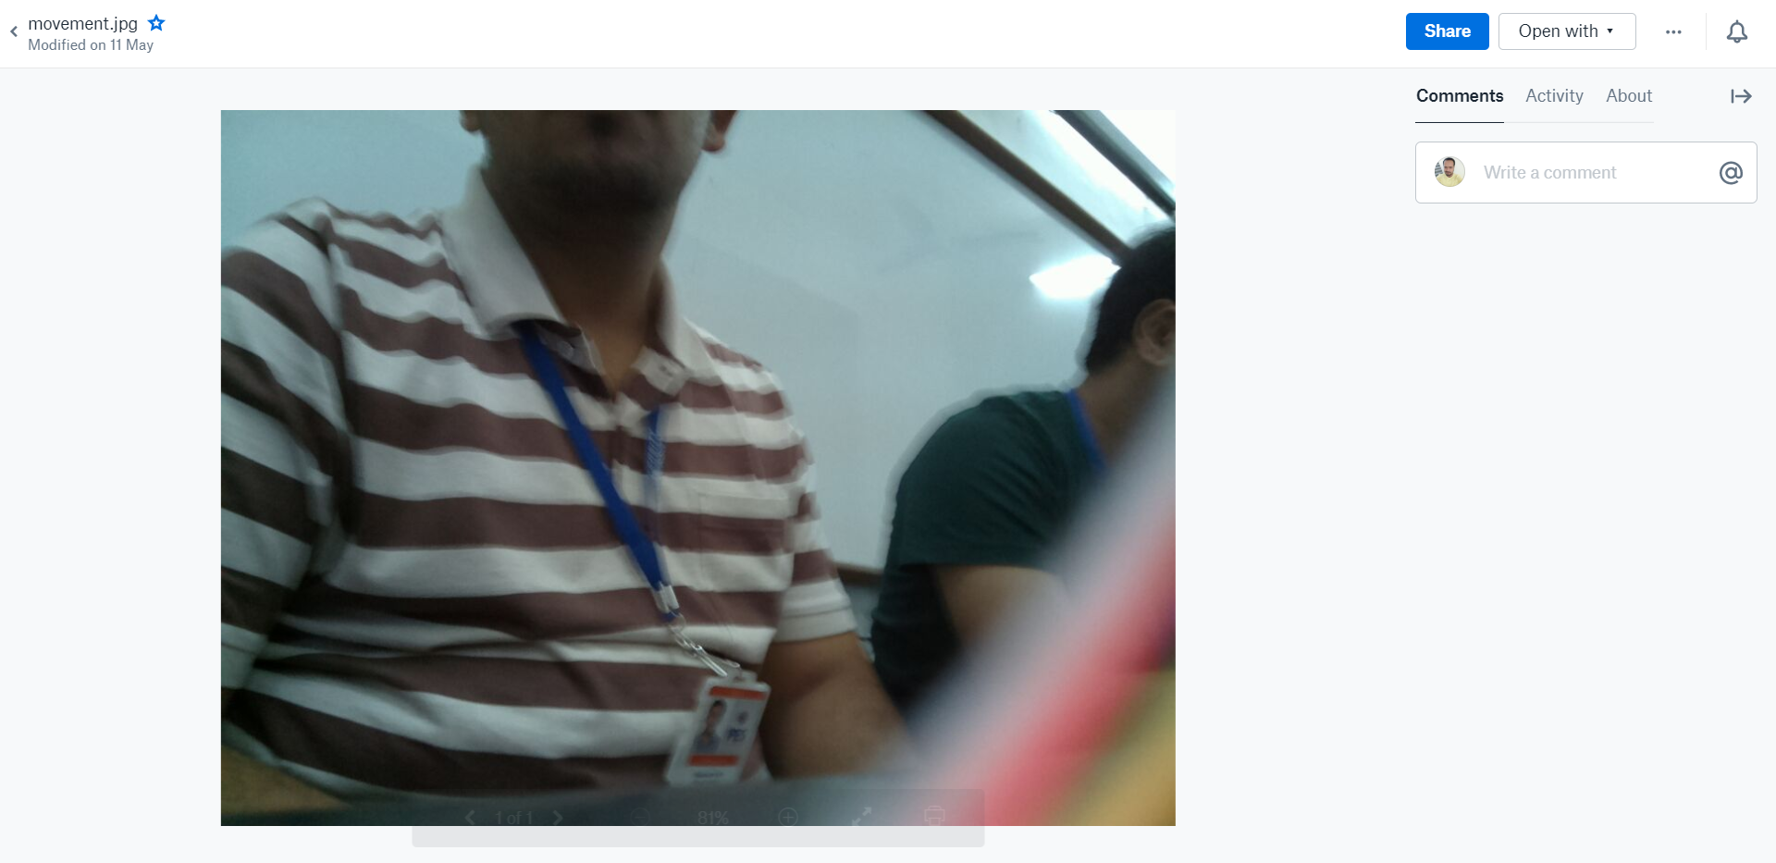

**TESTING**

|  |  |  |  |  |  |  |  |  |  |  |  |  |  |  |  |  |  |  |
| --- | --- | --- | --- | --- | --- | --- | --- | --- | --- | --- | --- | --- | --- | --- | --- | --- | --- | --- |
| **Test Case ID** | | 1 | | **Test Case Description** | | | Test the Smart Surveillance Functionality | | | | | | | | | | | |
| **Created By** | | Team | | **Reviewed By** | | | - | | | | **Version** | | | | - | | | |
|  |  | |  | |  |  | |  | |  | |  | |  | |  | |  | |
| **QA Tester’s Log** | |  | | | | | | |  | |  | |  | |  | |  | |
|  |  | |  | |  |  | |  | |  | |  | |  | |  | |  | |
| **Tester's Name** | | Team | | **Date Tested** | | | 12-May-2019 | | | | **Test Case (Pass/Fail/Not Executed)** | | | | Pass | | | |
|  |  | |  | |  |  | |  | |  | |  | |  | |  | |  | |
| **S #** | **Prerequisites:** | | | | |  | | **S #** | | **Test Data** | | | | | | | | | |
| 1 | Access to Smart Surveillance | | | | |  | | 1 | | Sensors | | | | | | | | | |
| 2 |  | | | | |  | | 2 | | Objects | | | | | | | | | |
| 3 |  | | | | |  | | 3 | |  | | | | | | | | | |
| 4 |  | | | | |  | | 4 | |  | | | | | | | | | |
|  |  | |  | |  |  | |  | |  | |  | |  | |  | |  | |
| **Test Scenario** | Check whether the sensor activates on motion detection and starts monitoring the environment. If yes, then it should capture the image and store it on cloud. | | | | | | | | | | |  | |  | |  | |  | |
|  |  | |  | |  |  | |  | |  | |  | |  | |  | |  | |
| **Step #** | **Step Details** | | | | **Expected Results** | | | **Actual Results** | | | | | | **Pass / Fail / Not executed / Suspended** | | | | | |
|
| 1 | Access the smart Surveillance | | | | Device is available | | | Device is available | | | | | | Pass | | | | | |
| 2 | Trigger the device | | | | ON | | | ON | | | | | | Pass | | | | | |
| 3 | Sensor detects motion | | | | Camera should get activated | | | Camera activated successfully | | | | | | Pass | | | | | |
| 4 | Starts monitoring the environment | | | | Camera should monitor the environment | | | Camera monitoring the environment | | | | | | Pass | | | | | |
| 5 | Capture the image | | | | Camera should capture the image of hostile person or object | | | Camera successfully captures the image | | | | | | Pass | | | | | |
| 6 | Store the image on Cloud – Dropbox | | | | The image must be stored onto the Dropbox | | | Image successfully stored into the Dropbox | | | | | | Pass | | | | | |
| 7 | No motion detected after stipulated time | | | | Device deactivates | | | Device deactivated successfully | | | | | | Pass | | | | | |

**CONCLUSION**

After analyzing the Indian-international borders we came to a conclusion that the main issue of our border is infiltrator because the borders are too vast and widespread. Hence, it is not possible to put individual army personnel everywhere on the border.

So finally, we came with an idea that by using modern technology such as IOT, it is very easy to build a project which can help the army personnel to keep an eye on the border like extreme geographic areas where it is hard to keep aware on the entire area.

**FUTURE ENHANCEMENT**

* Future enhancement of our project is to add Camouflage and LIDAR sensor to it.
* Internet of Things is a trending concept, which can increase the benefits of the smart surveillance by allowing it to adapt to the environment according to its changes ie if the Alligator is placed in the desert, it will change according to the desert’s atmosphere. Similarly, if it is placed in snowy regions, it will adapt to that atmosphere. Also by replacing PIR sensor with LIDAR (Light Detection and Ranging), which is a remote sensing method that uses light in the form of a pulsed laser to measure ranges (variable distance) the alligator will be able to detect motion from farther distances and will be able to alert the authorities much beforehand.
* In order to run this integrated set of hardware we can use solar panels as an alternative to the battery, which will be needed to run the alligator once it is deployed.

**BIBLIOGRAPHY**

1. [**https://www.raspberrypi.org**](https://www.raspberrypi.org)
2. [**https://thepihut.com/blogs/raspberry-pi-tutorials/16021420-how-to-install-use-the-raspberry-pi-camera**](https://thepihut.com/blogs/raspberry-pi-tutorials/16021420-how-to-install-use-the-raspberry-pi-camera)
3. [**https://www.youtube.com/watch?v=T8T6S5eFpqE**](https://www.youtube.com/watch?v=T8T6S5eFpqE)
4. [**https://projects.raspberrypi.org/en/projects/parent-detector/3**](https://projects.raspberrypi.org/en/projects/parent-detector/3)
5. <https://www.pyimagesearch.com/2016/04/18/install-guide-raspberry-pi-3-raspbian-jessie-opencv-3/>